**Guidelines**:

*Communications and Multimedia Committee*

Effective Date: 7/26/2016

Contact: [communications@jonesumc.com](mailto:communications@jonesumc.com)

newcover

Bishop Alfred Johnson, Senior Pastor Jones Memorial United Methodist Church 1975 Post Street

San Francisco, CA 94070-4157

Web: [www.jonesumc.com](http://www.jonesumc.com/) / Email: [office@jonesumc.com](mailto:office@jonesumc.com) Tel: (415) 921-7653 / Fax: (415) 921-7683

*Making Disciples of Jesus Christ for the Transformation of the World* 1

## Table of Contents

1. Announcements and Special Presentations During Worship 3
   1. Announcements 3
   2. Special Presentations 3
2. Intellectual Property 4
3. Written Communications 4
   1. Bulletin Announcements 4
   2. Correspondence 4
   3. Special Events 4
   4. Other Written Communications 5
4. Appendix A 6
5. Appendix B 7

*Making Disciples of Jesus Christ for the Transformation of the World* 2

## Announcements And Presentations During Worship

*Each Sunday’s worship experience is a “treasure” that we hope will be God-honoring and anointed. Our desire is not to curtail the announcements and special presentations, but to effectively and creatively communicate to a 21st century group of people who “take in" communications much more quickly than 10 years ago. It is also our desire to keep the focus of worship on God. It is with this backdrop that these guidelines are presented.*

#### Announcements

Effective January 1, 2010, all pulpit announcements are made by the Pastor or her designated representative.

If this policy changes in the future, here are the guidelines that will apply:

1. Only one (1) verbal announcement will be made from the lectern each Sunday unless deemed necessary by the Senior Pastor. This excludes communion Sunday in which case no additional verbal announcements will be made.
2. Announcements should be friendly and invitational to guests and visitors, as opposed to being “closed circuit” and exclusionary in language or spirit to guests or visitors.
3. Announcements should be pro-active and not reactive in nature. Announcements should not be made simply because someone neglected to communicate or needs a shortcut to communicate to their group.
4. Announcements are meant to augment and support personal invitation, not replace it.
5. Announcements should be typed and limited to no more than sixty seconds. Written announcements requests should be submitted to the church office no later than 4 p.m. on Tuesday.
6. Sunday “last minute” announcements will only be accepted for the following reasons:
   1. Church member illness, accident, or death;
   2. Response to world/national emergency;
   3. Weather-related changes; and
   4. Other Pastoral items deemed necessary by the Senior Pastor or Administrative Council.

#### Special Presentations:

1. Special presentations are done in addition to announcements and are reserved for special occasions and should be done in such a way as to not exclude visitors.
2. Special presentations should be limited to 3-5 minutes should include a faith based rationale for the presentation.
3. Special presentations should be pre-scheduled on the annual planning calendar so as to interface smoothly with the worship experience and other areas of church life.
4. Please create and submit a presentation outline and/or script that realistically addresse the subject matter and time limit. This is due to the office the no later than two (2) weeks (14 days) before the presentation.

*Making Disciples of Jesus Christ for the Transformation of the World* 3

## Intellectual Property

The Church respects the intellectual property (i.e. copyrights, trademarks, etc.) of all individuals, business, and organizations. To that end, you must provide written proof of the right to use the intellectual property (e.g. photographs, written documents, images, clip art, etc.) for any and all communications generated by or associated with the Church – this includes items downloaded from the Internet. *See* **Appendix B** for an example.

Written proof of the right to use said intellectual property must be submitted to the Communications / Multimedia chairperson at [communications@jonesumc.com.](mailto:communications@jonesumc.com) If you need assistance in meeting these requirements, contact the Communications/Multimedia chairperson.

## Written Communications

#### Bulletin Announcements:

Bulletin announcement requests should be submitted to the Church office no later than 4 p.m. on the Tuesday before the Sunday in which you want your announcement to appear. *See* **Appendix A** for the Bulletin / Announcement Request Form.

**Note**: The number of times that an announcement requesting **financial** donations will appear in the bulletin will be at the Pastor’s discretion.

Requests should be submitted to the office by hand, US Mail, facsimile (415-921-7653), or email (office@jonesumc.com).

#### Correspondence:

All correspondence sent from the Church must be submitted to the Church office for review and approval by the Pastor and for printing on the Church’s official letterhead. No one is allowed to print correspondence on their own “version” of the letterhead or to use the Church’s official letterhead – all correspondence must be printed by the office. We pray that this will reduce the instances of spelling and grammatical errors in official Church communications.

Requests should be submitted to the office by hand, US Mail, facsimile (415-921-7653), or email (office@jonesumc.com).

#### Special Events:

A draft of all bulletins, brochures, programs, etc. for all special events must be submitted to the Church office for review and approval by the Pastor.

Requests should be submitted to the office by hand, US Mail, facsimile (415-921-7653), or email (office@jonesumc.com).

*Making Disciples of Jesus Christ for the Transformation of the World* 4

#### Other Written Communications:

All communications (e.g. flyers, tickets, banners, posters, etc.) from the Church – including publicity – must be routed through the Communications / Multimedia chairperson and approved by Bishop Johnson **before** dissemination. The goal of this policy is to ensure that all Church communication is consistent, accurate, and in alignment with the Church’s mission.

Requests should be submitted digitally by hand on digital media or via email to [communications@jonesumc.com](mailto:communications@jonesumc.com) and [bishopj@jonesumc.com](mailto:bishopj@jonesumc.com)

**Note**: Please plan ahead as there will be a 2-3 week turnaround for the approval process.

#### Church Related Public/Media Appearances

Bishop Johnson is the official Representative of Jones Memorial United Methodist Church. No individual should represent the church in any media (television, radio, movie, etc.) without the expressed written permission of the Pastor or her designated representative(s).

*Making Disciples of Jesus Christ for the Transformation of the World* 5

## Appendix A

*Making Disciples of Jesus Christ for the Transformation of the World* 5

#### Jones Memorial United Methodist Church BULLETIN /ANNOUNCEMENT REQUEST FORM

Use the space below to describe your announcement or bulletin request.

Would you like your submission announced? Yes No Is your submission to be printed in the bulletin? Yes No

When would you like your submission printed or announced?

Day, Date & Time

How many weeks should your submission be printed or announced?

thru

Submitted by: Telephone No.: Dated Submitted:

If your information is in flyer format, please attach your flyer to this form.

PLEASE NOTE: THE **DEADLINE** FOR THE BULLETIN IS THE TUESDAY BEFORE THE SUNDAY IN WHICH YOU WANT YOUR REQUEST TO APPEAR BY **4:00 P.M.**

## Appendix B

*Making Disciples of Jesus Christ for the Transformation of the World* 6

**A l\1 E R I C A N M E M O R Y R o f** C O **N G ill**

**I, I B**

**.4 R )'**

# Selected Civil War Photographs, 1861-1865

**Rights and Reproductions**

Copyright and Restrictions I Availability of Reproductions I For Further Information

### Copyright and Restrictions

There are no known restrictions on these photographs. However, approximately fifty of the portraits of soldiers (mostly enlisted men) are copies of photographs that the Library of Congress borrowed during the

1950s and early 1960s. (The catalog records for these images contain a note field that begins "Copy photo made by LC . . . ."). After copying, the I

l

original photographs were returned to their owners but the Library did not **PREVI NE NEW** retain a record of he. owner's nams and addre_sses. he Library is not **OUS XT I SEA** aware of any restnct10ns on these images, but 1s anx10us to hear from **RCH** individuals or institutions that own the original photographs or who know

of their history.

Suggested credit line: Library of Congress, Prints & Photographs Division, [reproduction number, e.g., LC-B8184-3287]

For guidance about compiling full citations consult Citing Electronic Sources on the learning page.

More information about American Memory Collections, Copyright. and Other Restrictions is available.

### Availability of Reproductions

See the collection home page for information about the availability of reproductions of materials in this online collection.

### For Further Information

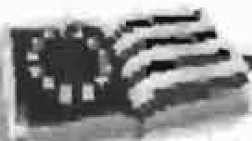

Ifyou have comments or additional questions, please contact us.



_ _ J _ J

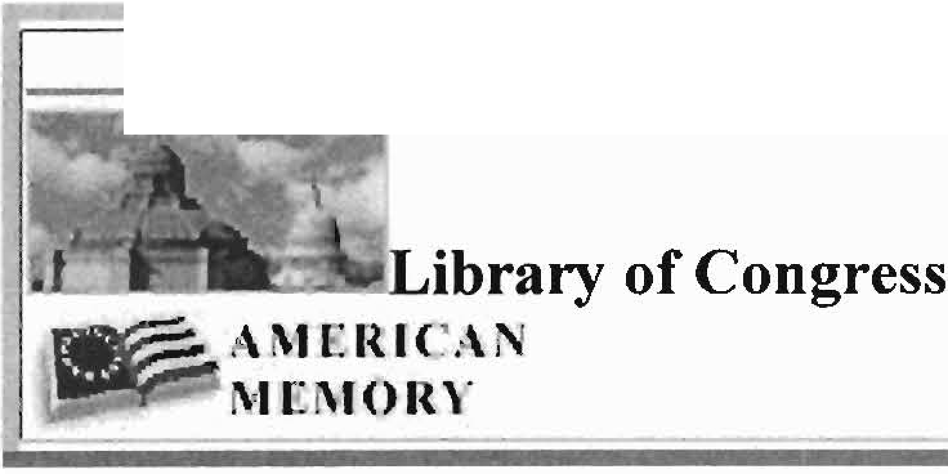

1

:;-;;i--

-1

_J

**Selected Civil War Photographs, 1861-1865**

*Click on picture for larger image,full item, or more versions.* [Rights and Reproductions]

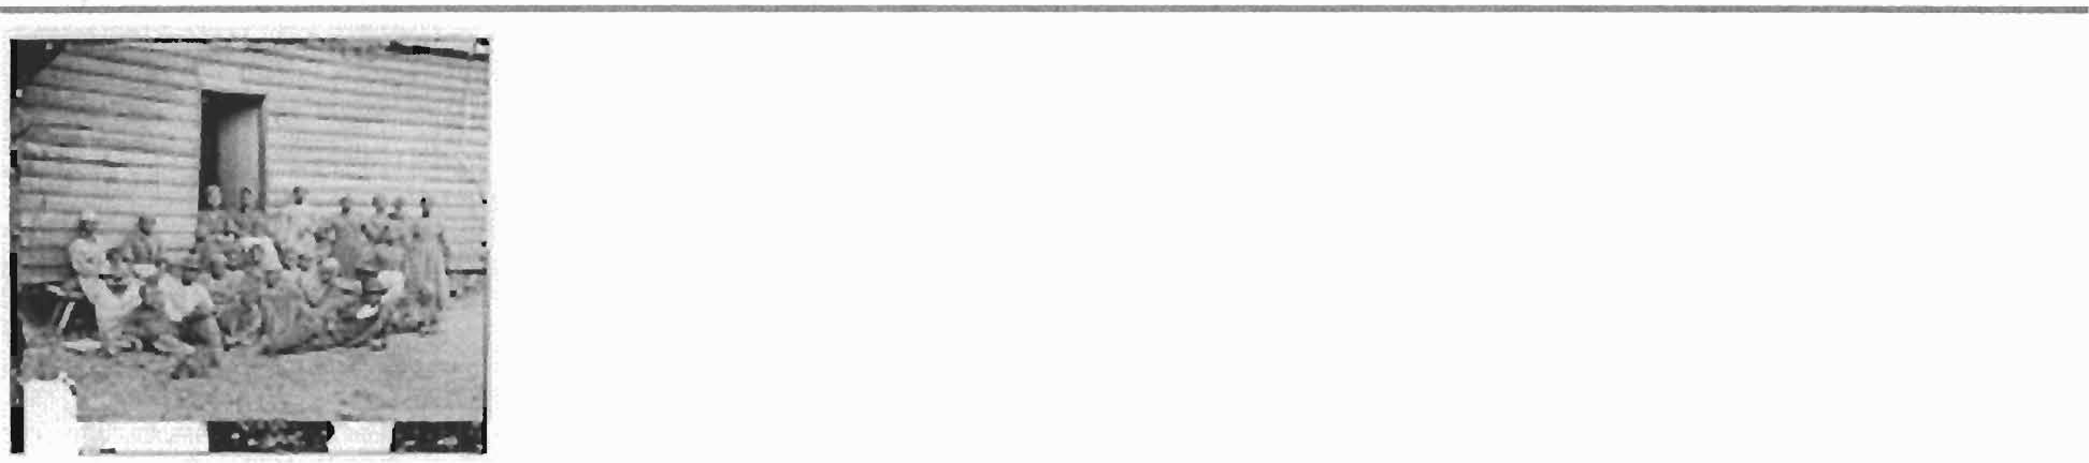

**[Cumberland Landing, Va. Group of "contrabands" at Foller's house]**

Gibson, James F., b. 1828, photographer.

**CREATED/PUBLISHED**

1862 May 14.

**SUMMARY**

Photograph from the main eastern theater of war, The Peninsular Campaign, May-August 1862.

**NOTES**

Reference: Civil War photographs, 1861-1865 *I* compiled by Hirst D. Milhollen and Donald H.

Mugridge, Washington, D.C. : Library of Congress, 1977. No. 0055 Title from Milhollen and Mugridge.

Stereo filed in LOT 4172-A.

Title information from ca. 1880 corresponding print in LOT 4172 B.

Forms part of Civil War glass negative collection (Library of Congress).

**SUBJECTS**

United States--History--Civil War, 1861-1865--African Americans. Peninsular Campaign, 1862.

Wet collodion negatives--1860-1870.

Stereographs--1860-1870.

United States--Virginia--Cumberland Landing.

MEDIUM

I negative : glass, stereograph, wet collodion .

CALL NUMBER LC-B81 l - 383

REPRODUCTION NUMBER

LC-DIG-cwpb-01005 DLC (digital file from original neg.) LC-B8171-0383 DLC (b&w film copy neg.)

SPECIAL TERMS OF USE

No known restrictions on pub;ication.

PART OF

Selected Civil War photographs, 1861-1865 (Library of Congress)

REPOSITORY

Library of Congress Prints and Photographs Division Washington, D.C. 20540 USA

DIGITAL ID

(digital file from original neg.) cwpb 01005 <http://hdl.loc.gov/loc.pnp/cwpb.01005> (digital file from intermediary roll copy film) cwp 4a39468

I

A M E R ICA N 'PREVIOUS INEXT 1i NEW SEARCH

M Et\lOI{\ 11------------................ .

MARY McLEOD BETHUNE MISSION GROUP OF JONES MEMORIAL UNITED METHODIST CHURCH PRESENTS

A PERFORMING ARTISTS CONCERT CELEBRATING

***PERFORMANCES BY***

**Lucy Kinchen Chorale, Lucy Kinchen Director**

**Sequoia High School Choir, Othello Jefferson Director**

**Fredrick Matthews, Operatic Baritone,**

**Member San Francisco Opera**

**Dr. Carl Blake, Pianist**

***SAVE THE DATE April 25th, 2010* – *3:00 P.M***

***Donation - $20.00.***

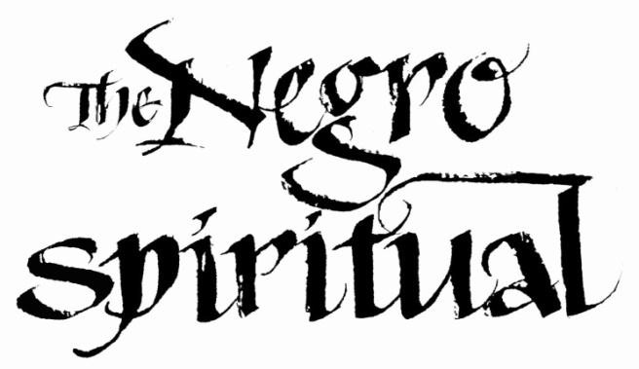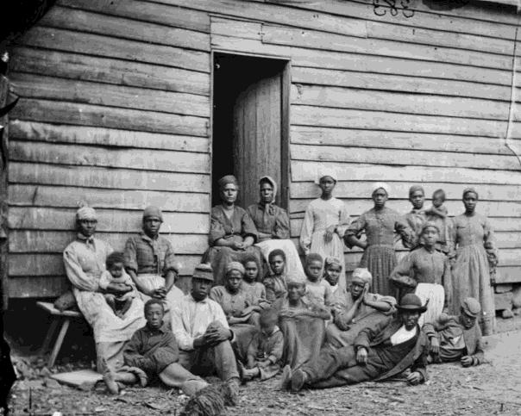

A National Treasure

Jones Memorial UMC 1975 Post Street

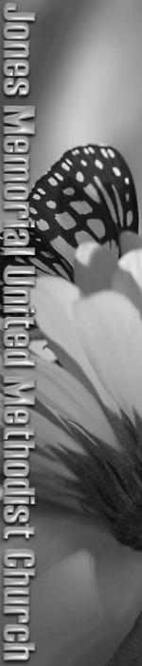

San Francisco, CA 94115

Bishop Alfred Johnson, Senior Minister Ms. Aleece J. Carson, Minister Of Music

Office: (415) 921-7653 / Fax: (415) 921-7683

E-mail: [office@jonesumc.com](mailto:office@jonesumc.com) Website: [www.JonesUMC.com](http://www.JonesUMC.com/)

Jones Memorial UMC 1975 Post Street



San Francisco, CA 94115

Bishop Alfred Johnson , Senior Minister Ms. Aleece J. Carson, Minister Of Music

Office: (415) 921-7653 / Fax: (415) 921-7683

E-mail: [office@jonesumc.com](mailto:office@jonesumc.com) Website: [www.JonesUMC.com](http://www.JonesUMC.com/)